**Job: App for Vision OS with AI component (maybe that is unique for this tech)**

**Idea Deadline: End of checkpoint 1 (have 1 or 2)**

**Team Role Contract Document (plan on google docs, design on canva)**

Ideas

Concerts and shows for remote viewers? (tickets and viewing)



Outfit app

* Scan the closet to pick an outfit based on temperature/occasion
  + Sc

Historic Reconstruction

* [See the Ancient World Through Virtual Reality | Smithsonian](https://www.smithsonianmag.com/innovation/see-ancient-world-through-virtual-reality-180962237/) (check this out)

Language Learning App

* Active translation (important for travelers)
* Be able to move in current environment and translate items by having them in view
* Be able to choose artificial environment for unique vocabulary experience and translate items there
  + Could be 3D modeled
* After scanning item to translate, the following could be included:
  + Translated word
  + Original language word
  + Pronunciation (words and maybe listening)
  + Example sentences using word
  + Option to save to a word bank
* From word bank, have the option to create flashcards for later studying or add words to specific collections to separate
* How would GenAI be used:
  + Would be used in generating example sentences, translating, and possibly identifying objects (need to test that portion)
* "instant feedback". For example, if you say something wrong, you get immediate correction
* <https://www.nonsense.com/en>
* **NOTE: check out Noun Town (oculus app)
* Scan an object, have a conversation about said object generated by AI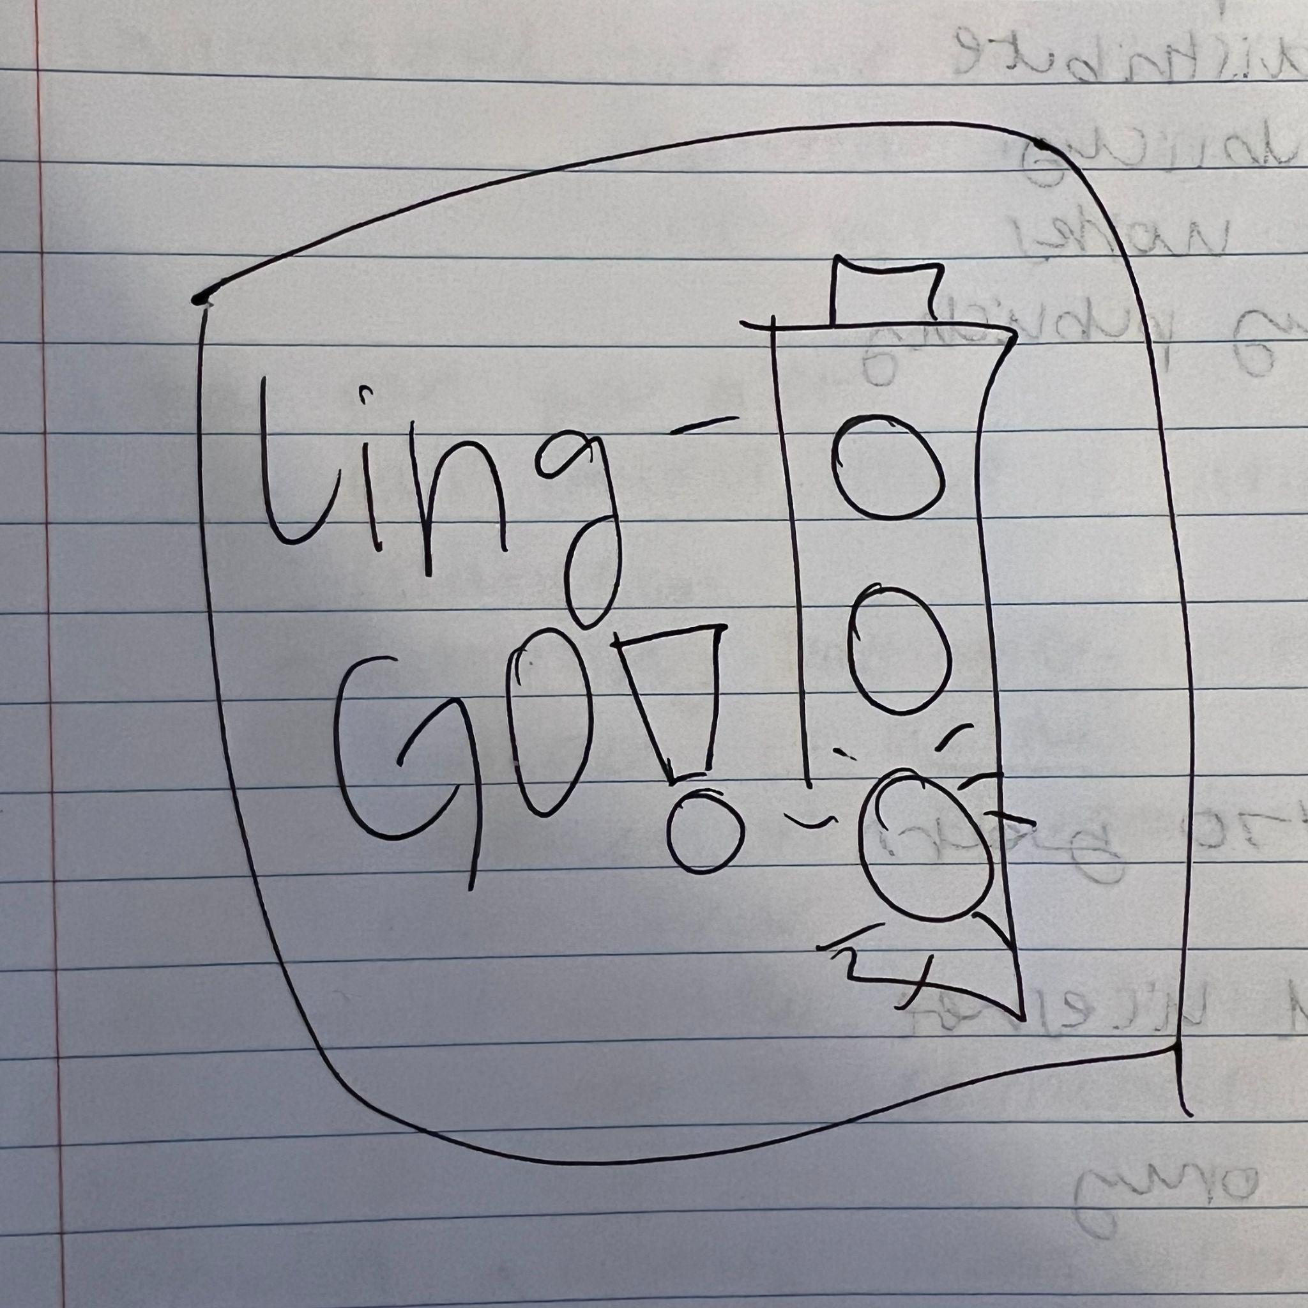

Recipe generation that examines your pantry and generates a recipe for you and guide you through it

“Time Travel” through time and generating areas of the world in the past

Something to aid architects and interior designers/decorators in building/designing/decorating spaces

Alpha/Beta

* Seeing if we can do mixed reality or one or the other
* Can we scan items in real time
* What GenAI are we using to translate/can do all of our features
* What will new users have available to them/what should we focus on